Understanding Homepages and Tiles

Fluid Homepages appear when you log in to the HR Direct PeopleSoft system. Homepages consist of a collection of tiles that show information to the end-user, and enable an easy way to navigate around the system. Homepages can be organized and delivered to end-users with tile content appropriate for specific roles, such as an employee or manager. Note: The system imposes a limit of 10 user-defined homepages.

Tiles provide a new navigational and informational structure and they allow users a quick way to perform routine tasks. Tiles give users direct access to targeted transactions.

Creating Your Own Homepage
A Homepage is a collection of tiles often grouped together for related work tasks.
- Navigate to any fluid homepage.
- Click on the Actions List icon and select Personalize Homepage from the menu.
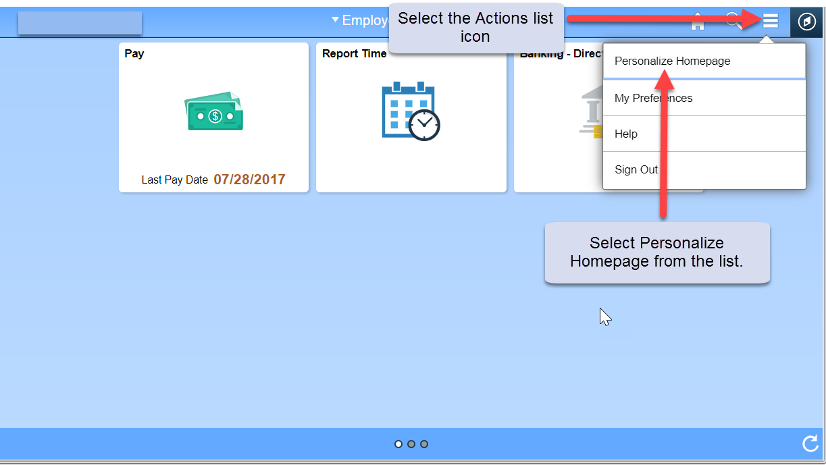
- From the Personalize Homepage screen, click on the Add Homepage button from the side bar on the left. The Add Homepage popup window is displayed.
- In the Add New Homepage edit box, enter the name of the new Homepage, and click the Add button. In the example below we created a homepage called “Customized Home Page”.
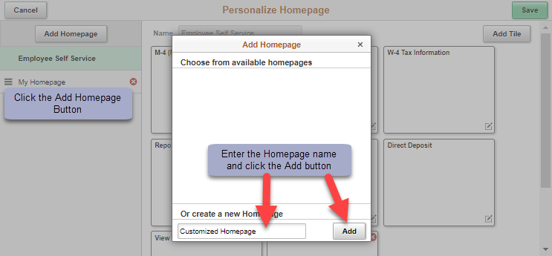

- The new Homepage is available for selection from the left-hand column on the Personalize Homepage screen.
- Click the Save button in the upper right corner to save your changes.

Adding a Tile to Your New or Existing Homepage
- Navigate to the page you want to add as a tile to a Homepage. (In this example: The user is navigating to the GT Action Center used for approving ePAF.)
- Click on the Action List menu icon in the upper right corner and select Add to Homepage.
- Select (choose) from available Homepages. (In this example: the user is adding the tile for the GT Action Center to the Customized Homepage)
- Click the Add button. You will get a message noting the tile has been successfully added.
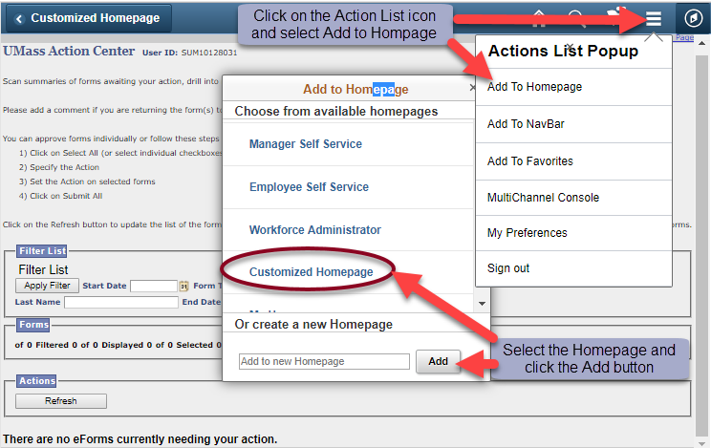
- To check that the tile did get added, navigate to Home, select the Homepage you added the tile to, and the new tile should be available. (In this example: GT Action Center has been added to the Customized Home Page).
